**Chapter 8**

**Result and Discussion**

The result was thoroughly analyzed and recorded at each step. The following are the results obtained after providing an input with of a blood smear containing sickle cells.

1. **Result of histogram stretching**

Histogram stretching (or normalization), is the process of improving or enhancing the contrast of an image. Contrast is the difference between maximum and minimum pixel intensity. This is performed in the software to obtain a clear distinction between a cell and its background.

Given Input: A gray scale image with poor contrast.

Expected Output: Improved contrast.

Observed Output: Better dynamic range and noticeable enhancement in contrast.

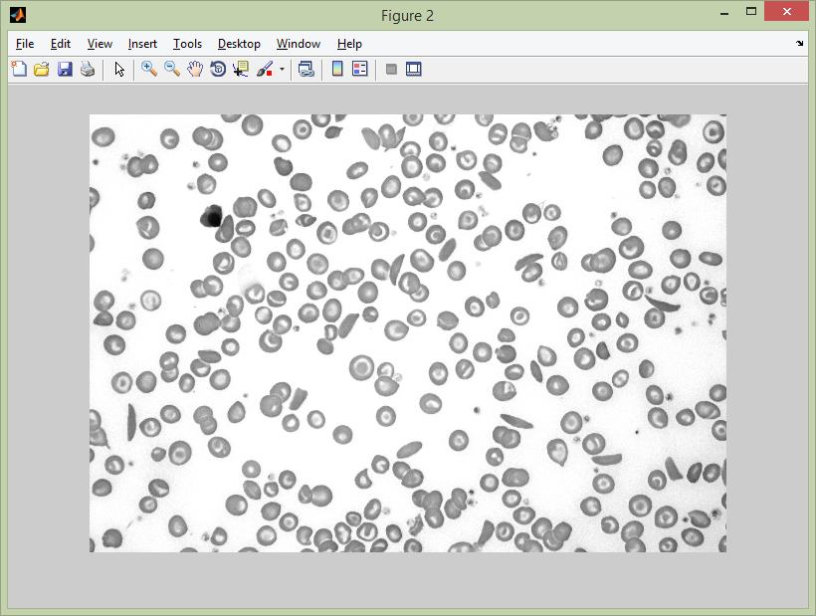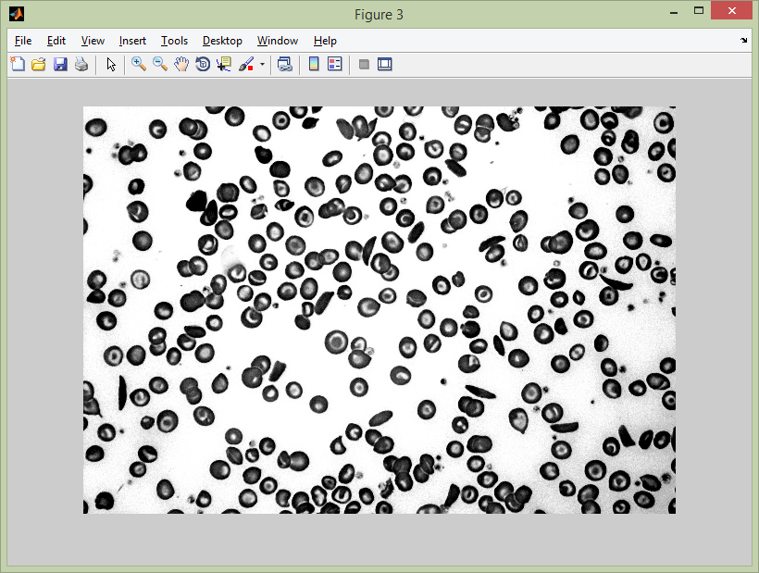

Input image

Observed output

Fig. 8.1. Result of histogram stretching

1. **Resulting image after imfill operator**

The cells contain void spaces within their centers. These have to be filled up, so that the whole cell can be detected as one object and its area can be calculated. So we use the imfill operator to achieve this.

Given Input: An image with cells having while nucleus.

Expected Output: Uniformly coloured cells.

Observed Output: The centers of the cells get filled with appropriate colours.

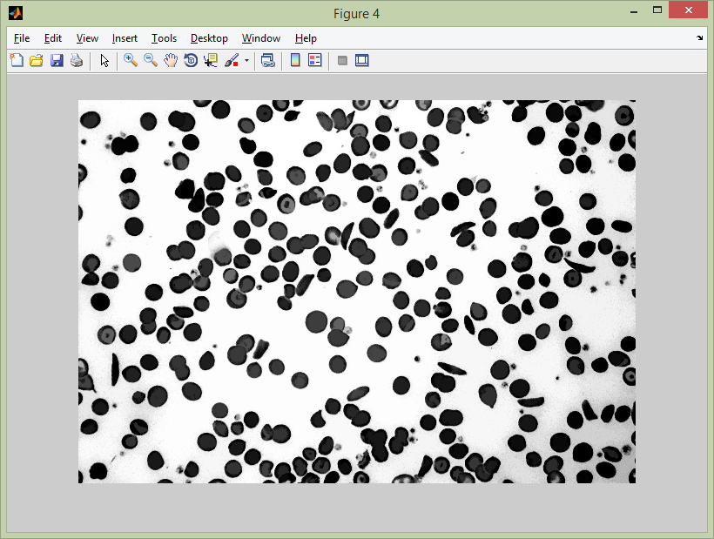

Observed output

Input image

Fig. 8.2. Resulting image after imfill operator

The result obtained from the above were analyzed and verified with the expected output. A randomized dataset consisting of 6 normal and 6 abnormal were used to estimate the accuracy of the software.

1. **Result of filtering the image**

There were small non RBC objects and other minute particles in the background of the sample image. These had to be eradicated to obtain appropriate result. This was done using bwareaopen.

Given Input: An image small objects and noise.

Expected Output: Only RBCs are retained.

Observed Output: The smaller objects are eradicated retaining only the actual RBCs.

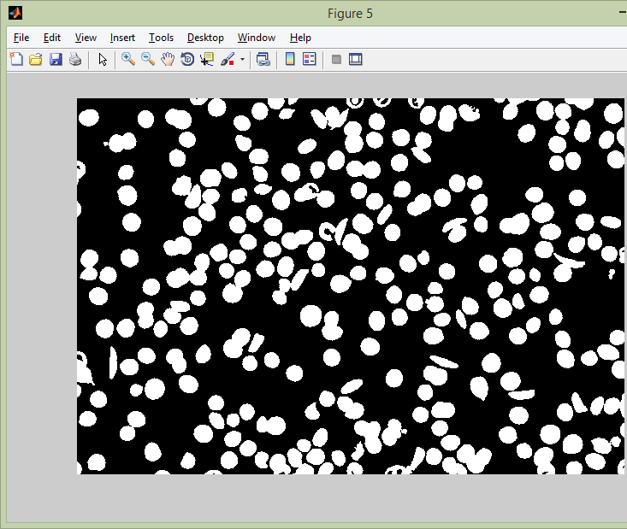 

Input image

Observed output

Fig. 8.3. Result of filtering the image

1. **Result of erosion and clearing the border objects**

The image was eroded and the border object were cleared. The erosion was performed to shrink individual objects with circular shape so that the ones being slightly overlapped become separated. The objects touching the border contain less information and is thus eliminated by using the imclearborder function.

Given Input: An image with overlapping objects and objects touching the boundary.

Expected Output: Individual cells being shrunk and objects touching the boundary eliminated.

Observed Output: Output as expected.

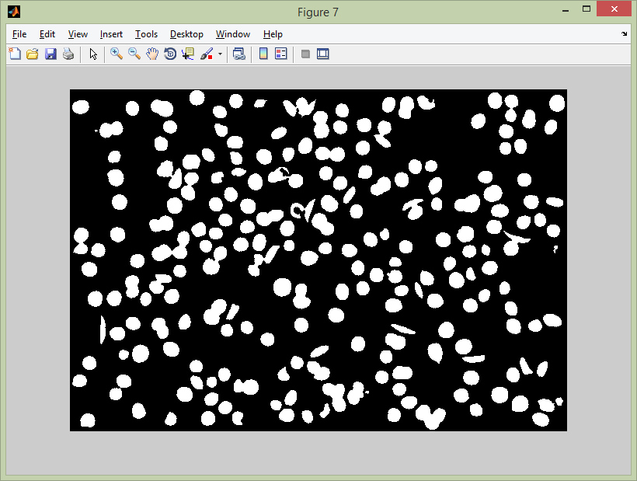

Fig. 8.4. Result of erosion and clearing the border objects

The final result obtained was recorded for a dataset of 10 randomized images. The findings were analyzed and the accuracy was calculated from it.

The following results were yielded from the dataset:

|  |  |  |  |  |  |
| --- | --- | --- | --- | --- | --- |
| Image | Valid Cells Found/Total | Abnormal cells | Threshold | Observed Result | Actual Status |
| Exhibit 1 | 267/341 | 9 | 26.7 | Healthy | Healthy |
| Exhibit 2 | 256/333 | 11 | 25.6 | Healthy | Healthy |
| Exhibit 3 | 188/210 | 26 | 18.8 | Anaemic | Anaemic |
| Exhibit 4 | 164/188 | 18 | 16.4 | Anaemic | Anaemic |
| Exhibit 5 | 244/295 | 14 | 24.4 | Healthy | Healthy |
| Exhibit 6 | 189/216 | 29 | 18.6 | Anaemic | Anaemic |
| Exhibit 7 | 65/73 | 1 | 6.5 | Healthy | Healthy |
| Exhibit 8 | 46/53 | 4 | 4.6 | Healthy | Anaemic |
| Exhibit 9 | 186/209 | 25 | 18.6 | Anaemic | Anaemic |
| Exhibit 10 | 46/63 | 1 | 4.6 | Healthy | Healthy |

Table 8.1. Result analysis

From the above analysis, it is seen that ASCAD provided the expected results in 9 out of the 10 samples used. We can therefore conclude that the software has an accuracy of about 90%. However, a thorough analysis with a much larger dataset would be required before we can determine its real accuracy. This was unfortunately not possible in our project owing to insufficient data available to us.

The data obtained by us were from foreign organizations that had made the medical data available to public domain. One of the reasons for insufficient data regarding sickle cell anaemia in India was found to be due to lack of digitalization of medical data and reluctance of both public and private institutions in sharing information for R&D. This hinders the software from realizing its true potential. But it wouldn’t be a stretch to assume that this would change in the near future as digitalization spreads deeper into India and digital records become mainstream.